Force and Motion Predictions

Name ______________________________

Think about using a rubber band to sling shot a heavy steel marble across the floor. The rubber band will be attached to a block of wood resting on a bed of straws on the floor. The rubber band will be pulled back and held in place with a string. The apparatus (looking down from above) will kind of look something like this:
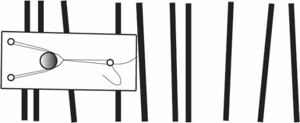
Then you cut the string. Describe, with a labeled drawing and explanation what you think what would happen to both the marble and the cart when you cut the string. This is just your hypothesis, a reasonable, good guess about what you think might happen.

Make a list of all the possible measurements you think you could make in this experiment, based on what you might already know about moving objects.

What do you think you could do with the above quantities? What could you be able to calculate from these measurements?

